***PAAREES PERFUMES***

***DAVID OFF***

***FOR WOMEN***

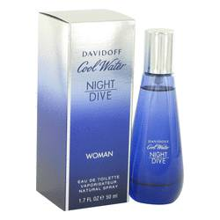

***Cool Water Night Dive***

***Description:***

Cool Water Night Dive by Davidoff Perfume. Bask in the scent of Cool Water Night Dive, a women's fragrance designed by Davidoff and introduced to the public in 2014. Mandarin breaks through the fragrance with crisp top notes, followed by the clean, fresh aroma of lentisque. Floral notes of jasmine swirl through the blend, enhanced by the nutty fragrance of pistachio and the earthy aroma of cedar. Splash a bit on before you go out to garner attention, whether you are at work or on a date.